GameDev Lab 1 Game Design Concepts

**Overview:** This week, we’ll examine a physical/analogue board, card or pen and paper roleplaying game (RPG) and develop some key features and selling points that are a starting point for game design and development.

**Instructions:**

1. Using the lab time provided and one of the games supplied by the instructor in the class, you’re (and up to one partner) should review the game, game rules, story, etc.
2. Answer the questions below in a D2L Discussion forum your instructor will set up.
3. Develop a ‘Back of the Box’ and a 1 page Game Design Document (GDD), both of which you will see samples for at the end of this document. This content should be deposited in a D2L group drop box for the instructor’s review.

**Questions:**

1. Provide a brief description of the game you reviewed, including its name, format, number of players, intended age/market, genre, etc.
2. Try to start a game. How long did it take to start a game, make characters, or get enough of the game rules under your belt in order to start play? This answer will change depending on your game, of course, but understand that we’re asking about that learning curve to get going with the product.
3. Imagine you are going to convert this game into a video game (e.g. think about your Back/Box and GDD as well) and briefly describe 2-3 major challenges you foresee with doing so successfully. Will this be too intense a game to simulate? What about artistic assets? Multiplayer requirements versus AI? Etc. Think about SOFTWARE based challenges versus things like getting a license to a popular movie.

**Back of the Box**

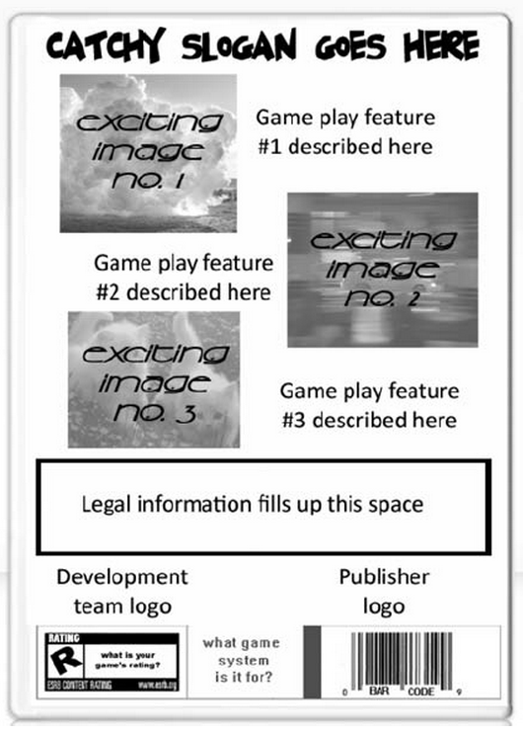

**WRITING THE GDD: THE ONE-SHEET**

The one-sheet is a simple overview of your game. It is going to be read by a variety of people including your team mates and publisher, so you need to keep it interesting, informative and most importantly, short. It should be no longer than ... you guessed it ... a single page. You can create them anyway you'd like, just as long as you include the following information:

* Game title
* Intended game systems
* Target age of players
* Intended Entertainment Software Rating Board (ESRB) rating
* A summary of the game's story, focusing on gameplay
* Distinct modes of gameplay
* Unique selling points
* Competitive products.

Most of these terms are self-explanatory, but here are a few you may not know:

**ESRB RATINGS**

The ESRB is the American rating system. There are several other international systems including the Pan-European Games Information (PEGI), the UK's British Board of Film Classification (BBFC), and Germany's Unterhaltungssoftware Selbstkontrolle (USK). Their age and content restrictions vary by country.

The ESRB is a self-regulatory organization that enforces a rating system as well as advertising and online privacy principles for software in the United States and Canada. The ESRB's creation is similar to the comic book industry's Comics Code, which was created to enforce content and morality guidelines in conjunction with concerned parent groups. However, the ESRB's rating system more closely resembles that of the MPAA's movie rating system (G, PG, PG-13, R, X). Games are reviewed and assigned a letter rating according to content.

Currently, there are six ratings that can be assigned by the ESRB:

**eC (Early Childhood):** contains no material parents would find inappropriate.

**E (Everyone):** may contain fantasy, cartoon or mild violence, and infrequent use of mild language.

**E10 (Everyone 10+):** may contain more fantasy, cartoon or mild violence, and mild language and suggestive themes.

**T (Teen):** may contain violence, suggestive themes, crude humor, minimal blood, and infrequent use of strong language.

**M (Mature 17+):** may contain intense violence, blood and gore, sexual content, and strong language.

**AO (Adults Only 18+):** not suitable for people under 18—may contain prolonged scenes of intense violence, graphic sexual content, and nudity.

While the ESRB's guidelines are effective in informing parents what titles are appropriate for their children, there is stigma attached to some of the ratings within the development community and fanbase.

Many gamers consider eC to be for "baby games", as this rating most frequently appears on edutainment and licensed titles for young audiences. At the other end of the scale, no brick and mortar retailer in America will carry a game with the AO rating. It's the industry's equivalent to an X rating in film. Therefore most publishers and developers won't even consider making games for this rating and will take great pains to prevent their titles from having this rating**[[]](javascript:moveTo('CHP-4-FN-04');)**.

[] This happened on The Punisher (THθ, 2005), where the player could curb-stomp and feed criminals into a woodchipper during interrogations. The scenes were so graphic that the developer changed the camera angles and displayed the action in black and white to bring the AO rating down to an M.

**Competitive products** (or **"comps**") are games that are similar to your game design idea that have already been released. Listing comps helps your reader understand what your game is going to be about. However, make sure that when you choose your comps you pick games that people are (a) very familiar with or (b) are successful. Publishers and marketers are very aware of how well or poorly a game sold. If you choose a comp of a game that did badly, a potential publisher may get scared off. Like I say, "always pick a winning horse."

**Unique selling points** (or **USPs**) are the "bullet points" found on the back of the box. As a rule of thumb, there should be around five USPs. (A number I developed when I realized you can only really fit five bullet points on the back of a game box.) Remember "amazing graphics" and "awesome story" or "sequel to the award-winning game" don't count. All games should have or be these things (though only if it actually is a sequel in the case of the last one). Besides, gamers can smell that marketing BS a mile away. USPs should be the unique features that make your game stand out from the crowd. Here are some examples. Let the spin begin!

* Multiple gameplay modes, including 256-player cooperative gameplay.
* Over 1000 tunes from popular bands.
* Explore an open world and 200 levels that allows the player to go anywhere.
* Mow through your enemies using the blastinator, the skull-defiler, and the awesome fire-ant anguisher!
* Experience lifelike physics and groundbreaking special effects with the new Realitech engine!
* Download additional costumes and content over the Internet.

As you can see, USPs should get the reader excited about the features of a game without going into lengthy detail about them. Exposing more of that detail is what the ten-pager is all about.

